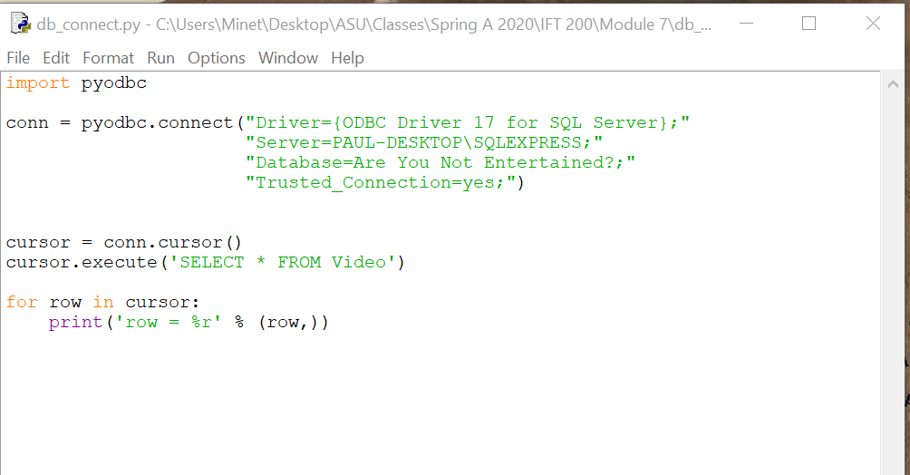

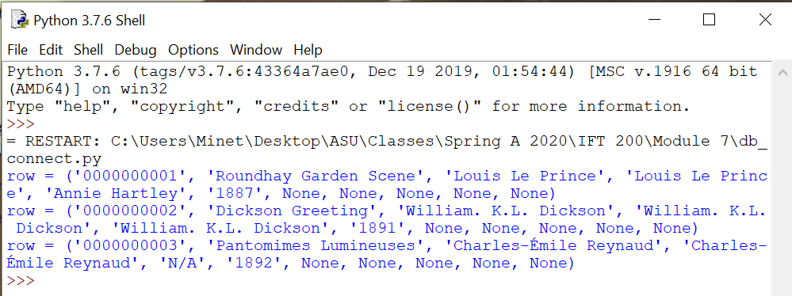

import pyodbc

conn = pyodbc.connect("Driver={ODBC Driver 17 for SQL Server};"

"Server=PAUL-DESKTOP\SQLEXPRESS;"

"Database=Are You Not Entertained?;"

"Trusted_Connection=yes;")

cursor = conn.cursor()

cursor.execute('SELECT * FROM Video')

for row in cursor:

print('row = %r' % (row,))

cursor.execute('SELECT * FROM Payment')

for row in cursor:

print('row = %r' % (row,))

cursor.execute('SELECT * FROM MyVideosList')

for row in cursor:

print('row = %r' % (row,))

cursor.execute('SELECT * FROM Subscription')

for row in cursor:

print('row = %r' % (row,))

cursor.execute('SELECT * FROM Search')

for row in cursor:

print('row = %r' % (row,))

cursor.execute('SELECT * FROM AccountsReceivable')

for row in cursor:

print('row = %r' % (row,))

cursor.execute('SELECT * FROM Series')

for row in cursor:

print('row = %r' % (row,))

cursor.execute('SELECT * FROM Movie')

for row in cursor:

print('row = %r' % (row,))

cursor.execute('SELECT * FROM Genre')

for row in cursor:

print('row = %r' % (row,))

cursor.execute('SELECT * FROM UserAcctUserCustomer')

for row in cursor:

print('row = %r' % (row,))

cursor.execute('SELECT * FROM PaymentInfo')

for row in cursor:

print('row = %r' % (row,))

cursor.execute('SELECT * FROM Comedy')

for row in cursor:

print('row = %r' % (row,))

cursor.execute('SELECT * FROM SciFiHorror')

for row in cursor:

print('row = %r' % (row,))

cursor.execute('SELECT * FROM ActionAdventure')

for row in cursor:

print('row = %r' % (row,))

cursor.execute('SELECT * FROM Romance')

for row in cursor:

print('row = %r' % (row,))

cursor.execute('SELECT * FROM Family')

for row in cursor:

print('row = %r' % (row,))

cursor.execute('SELECT * FROM Drama')

for row in cursor:

print('row = %r' % (row,))

cursor.execute('SELECT * FROM ForeignFilm')

for row in cursor:

print('row = %r' % (row,))

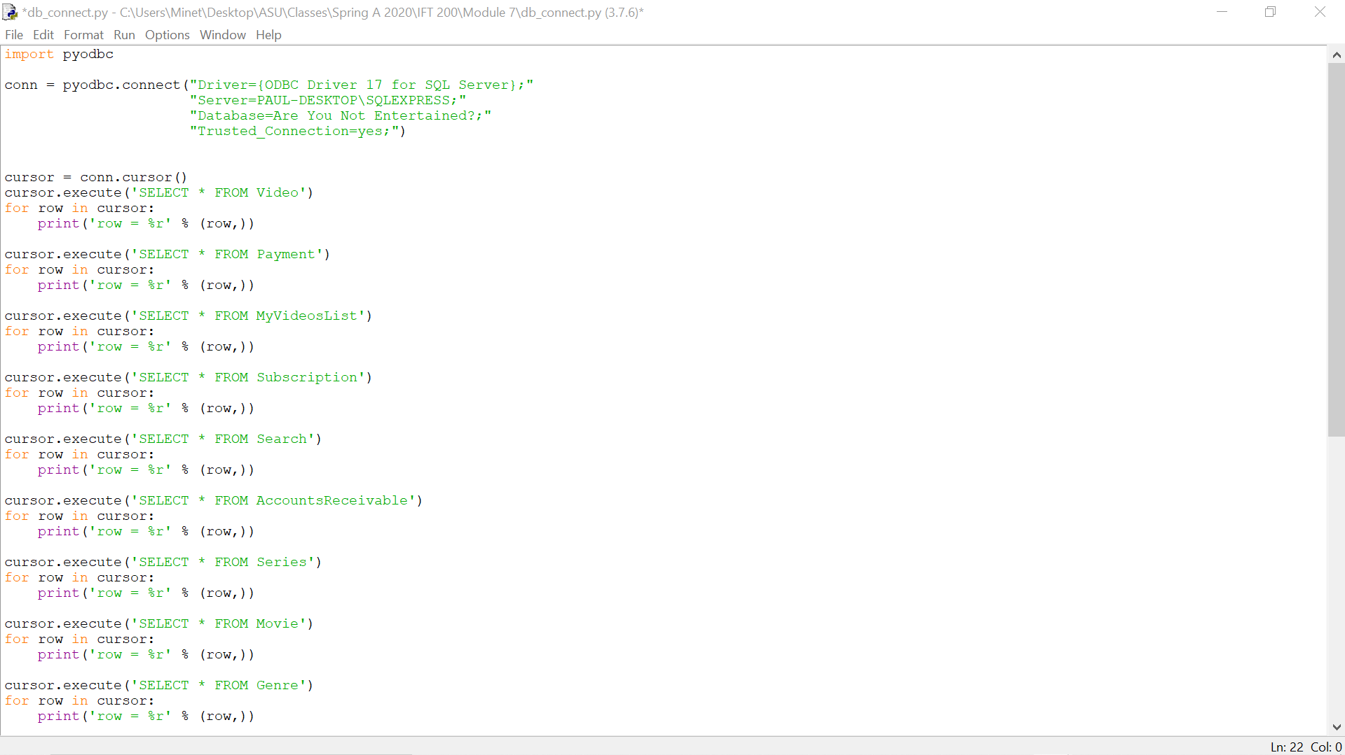

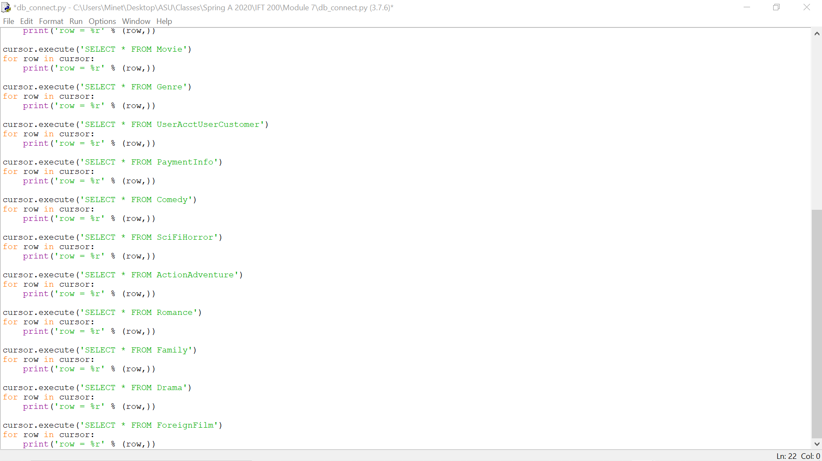

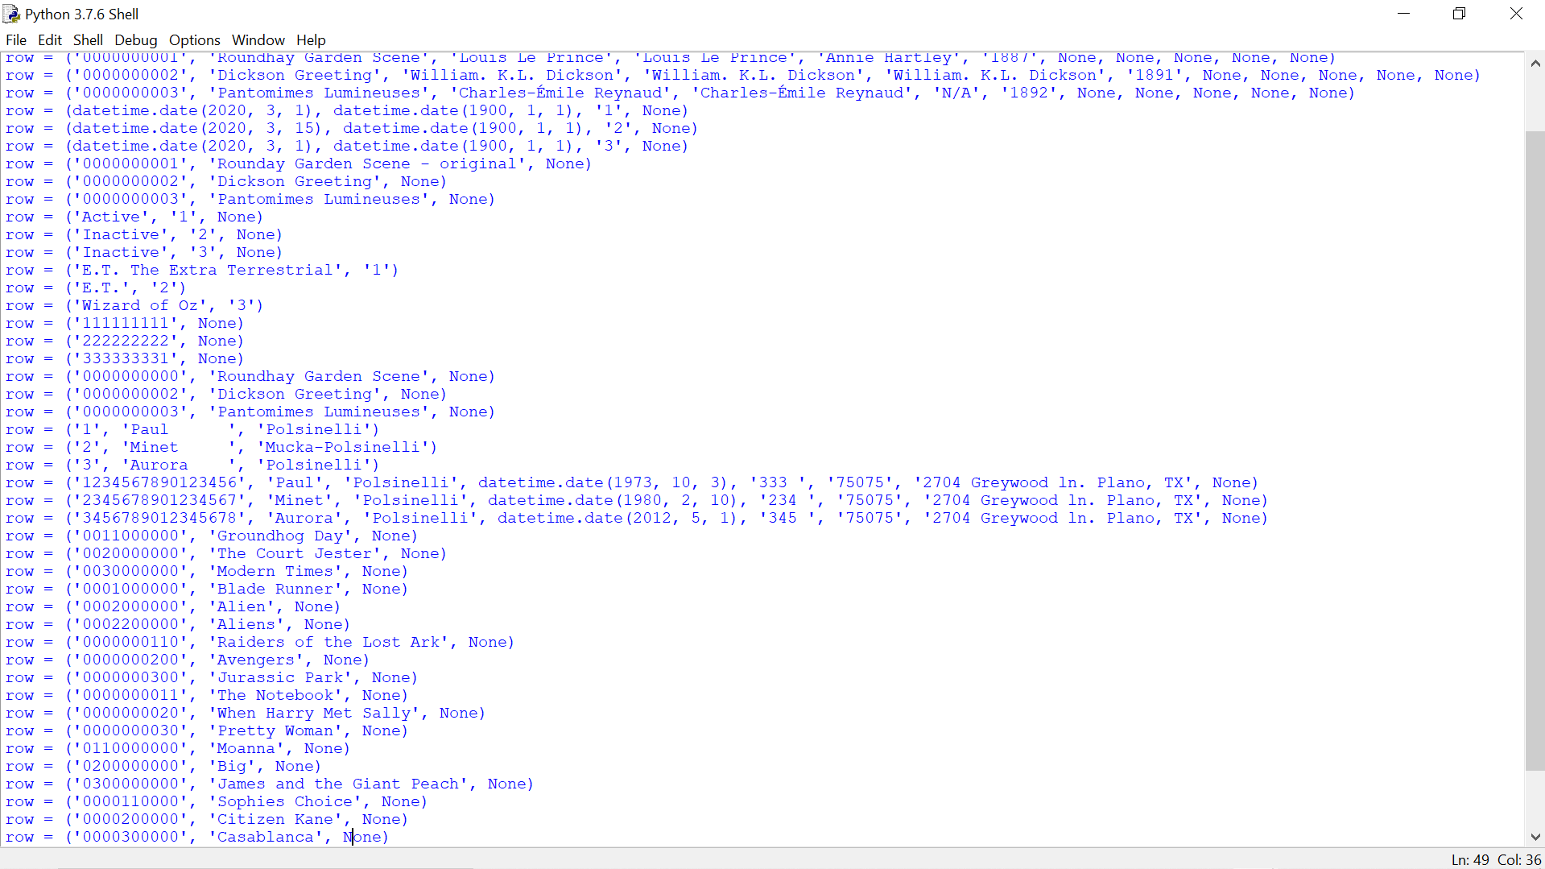



cursor.execute('Insert into AccountsReceivable ([Bank acct #]) values (444444444)')

